Assignment Day-15 & 16

**1.Working with Lambda :-**

* Creating two S3 buckets i.e source and destination:

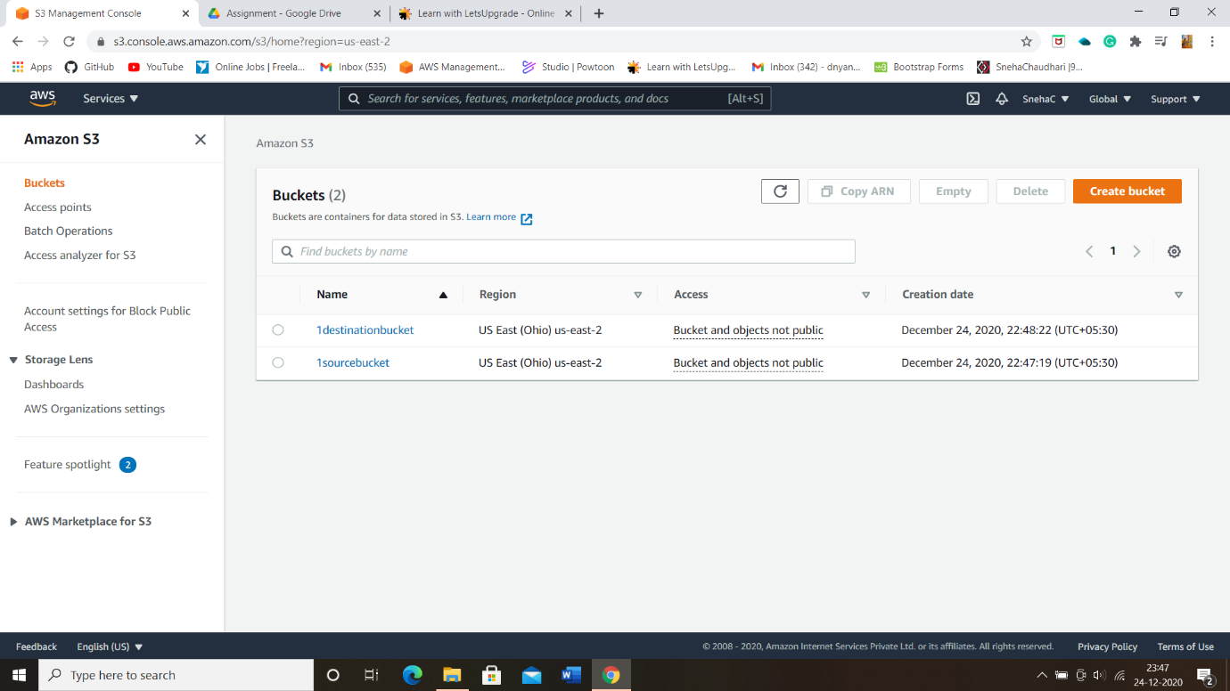

* Creating a policy with Read-Write permissions using JSON script:

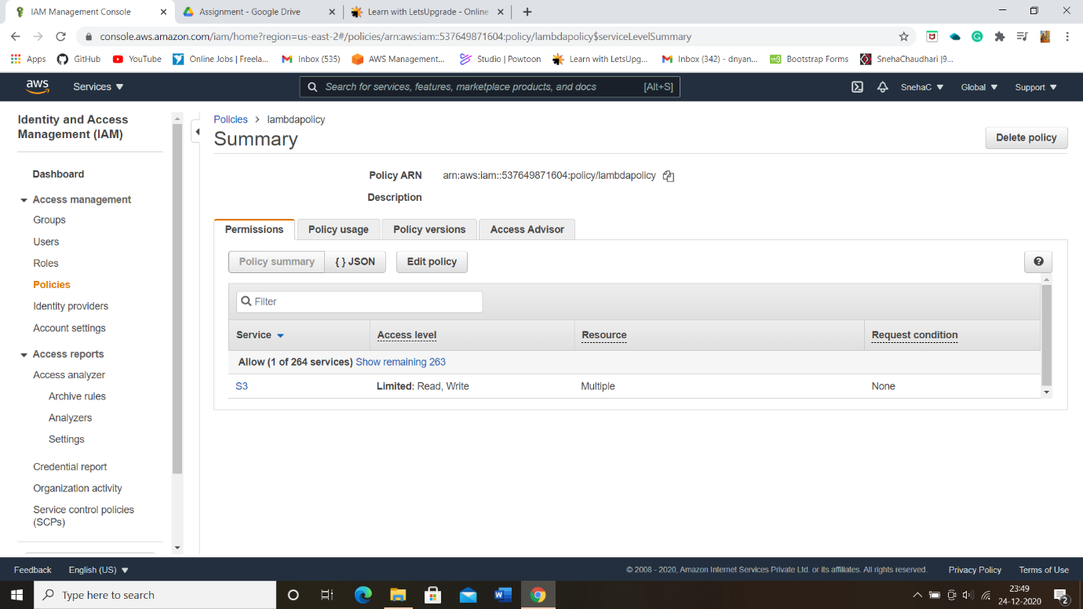

* JSON script with address of source and destination of S3 bucket:

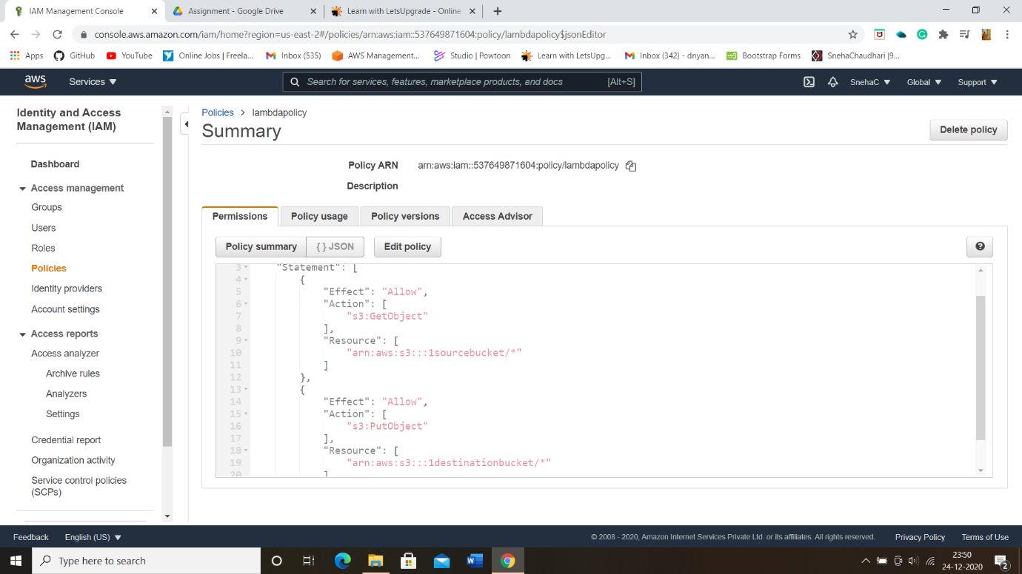

* Created policy console with policy filtered:

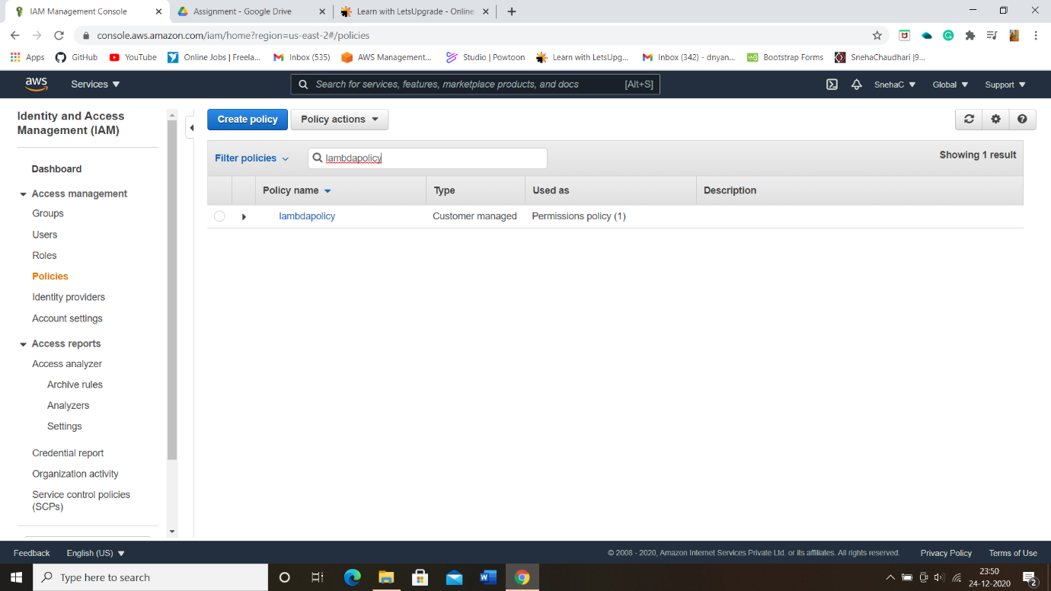

* Creating a role and attached policy which we created (Role Details):

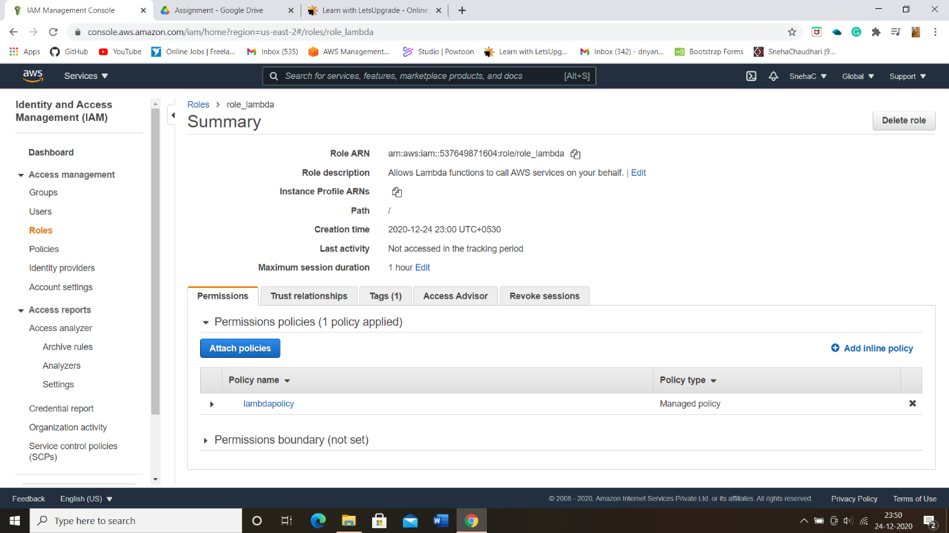

* Now creating a Lambda function:

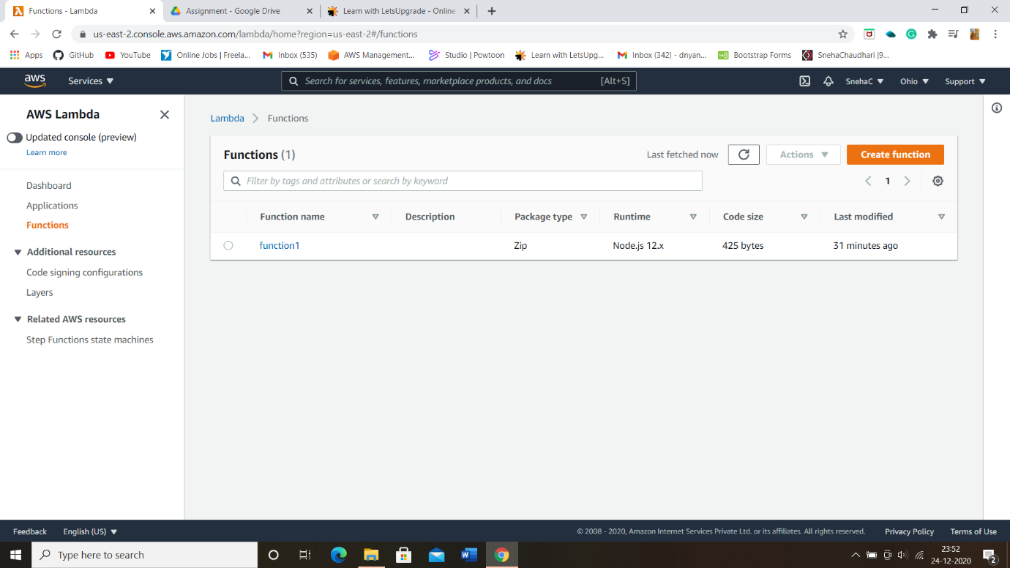

* Configuration page where trigger i.e S3 sourcebucket is added:

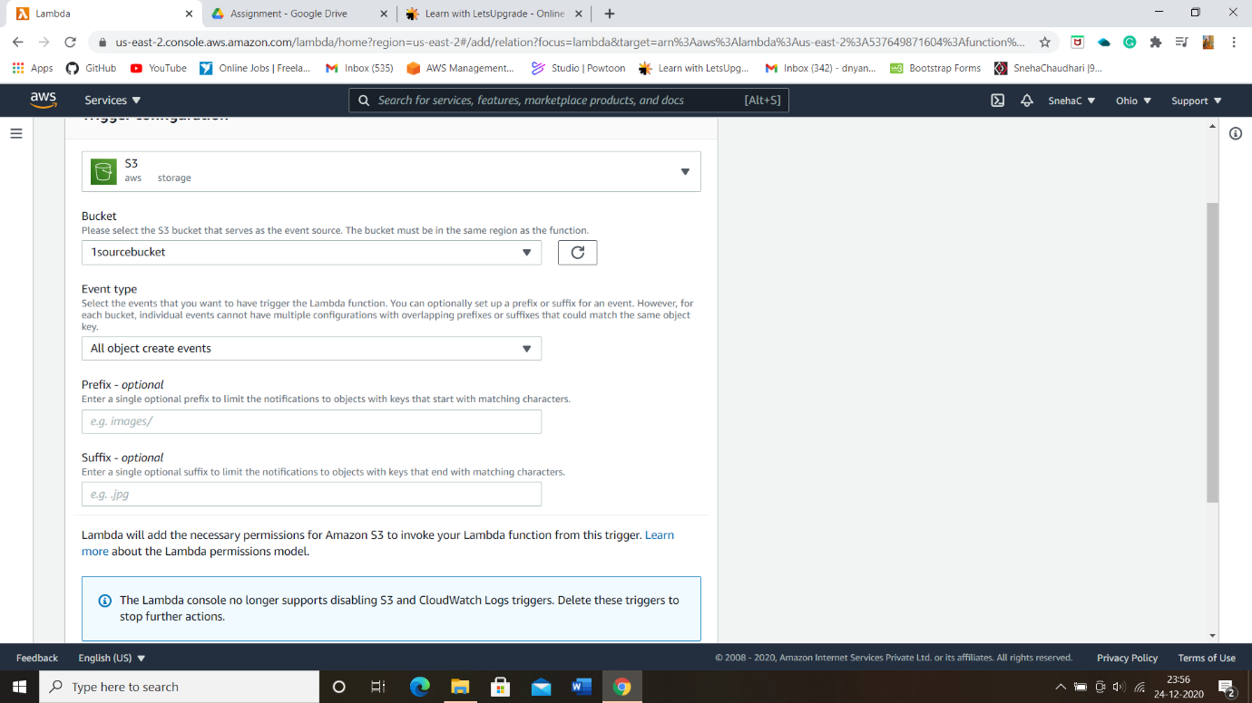

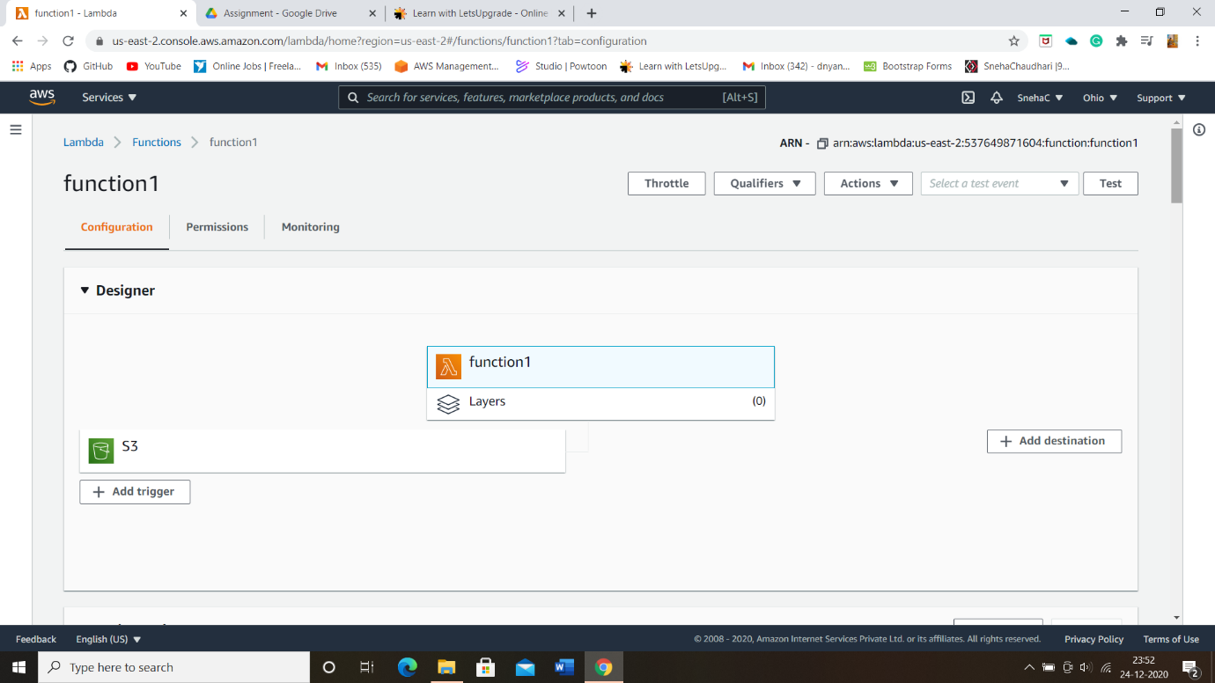

* Function javascript code for connecting both source and destination bucket:

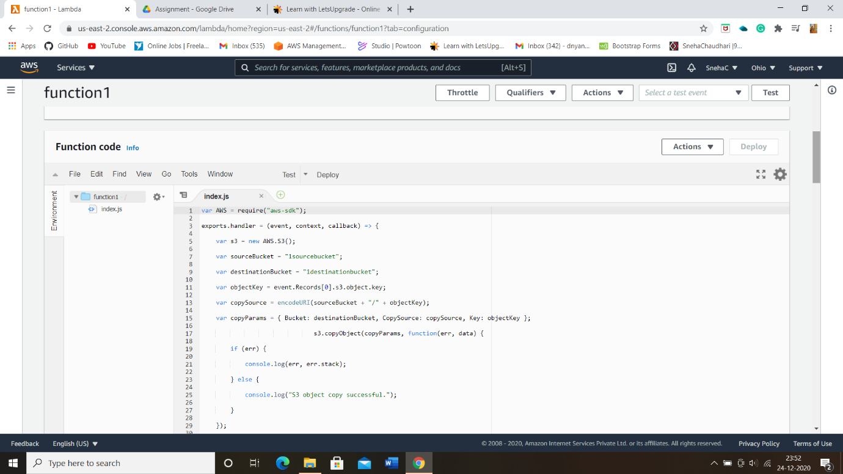

* Permissions page lambda function:

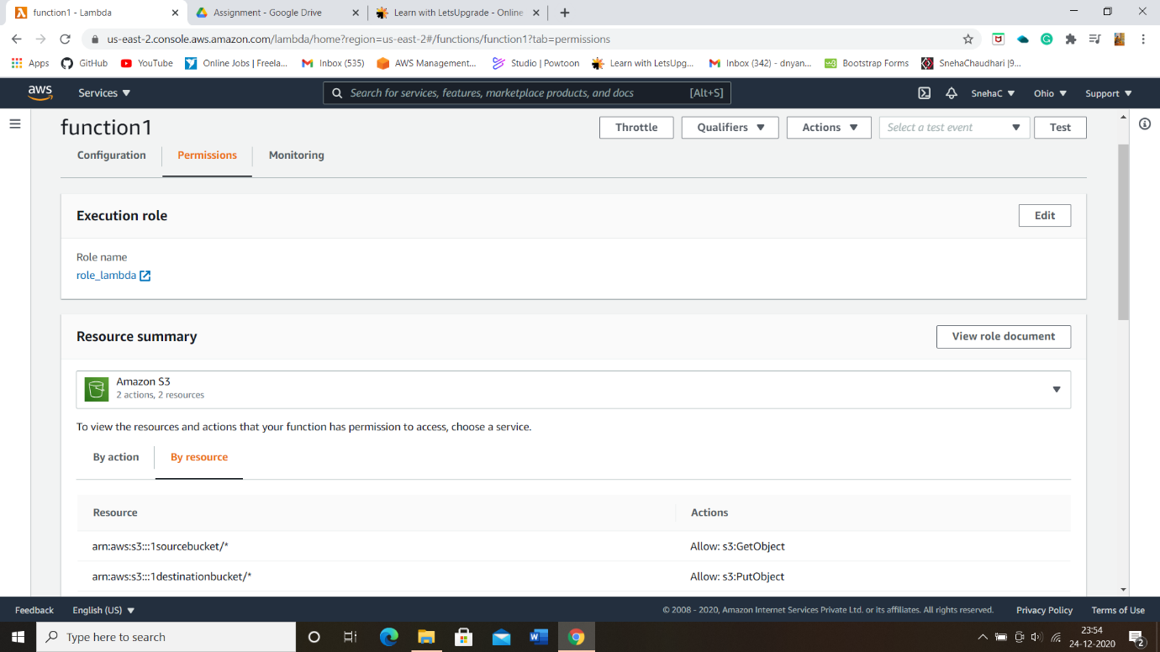

* Uploading a image in a sourcebucket:-

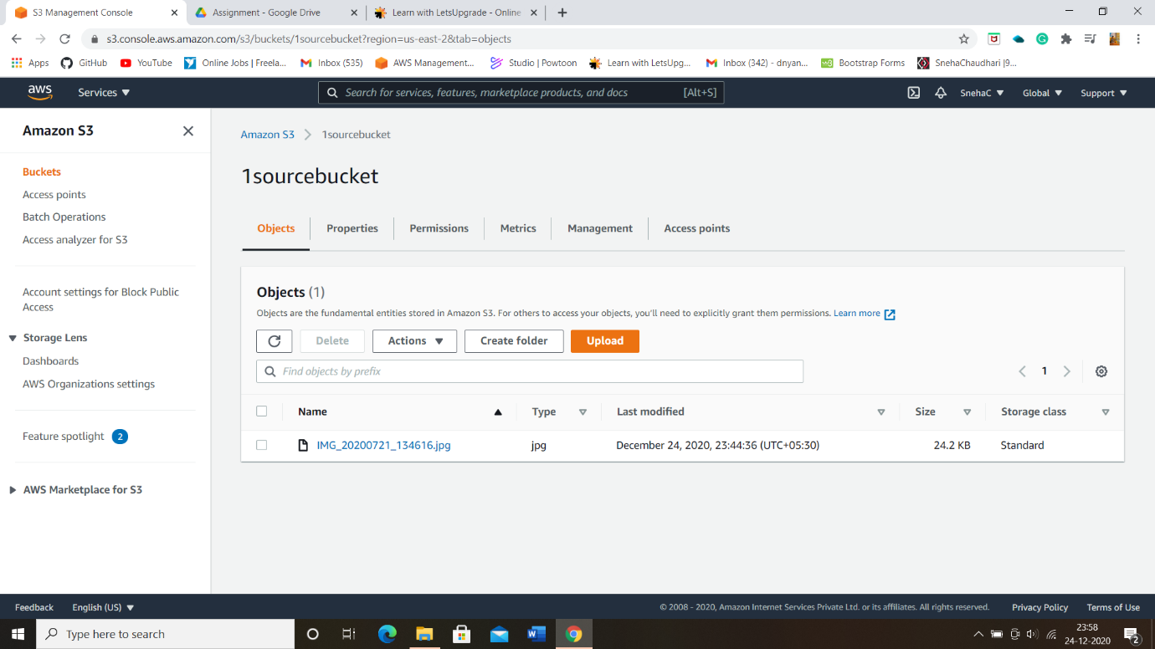

* Checking whether same image file is uploaded in destinationbucket:

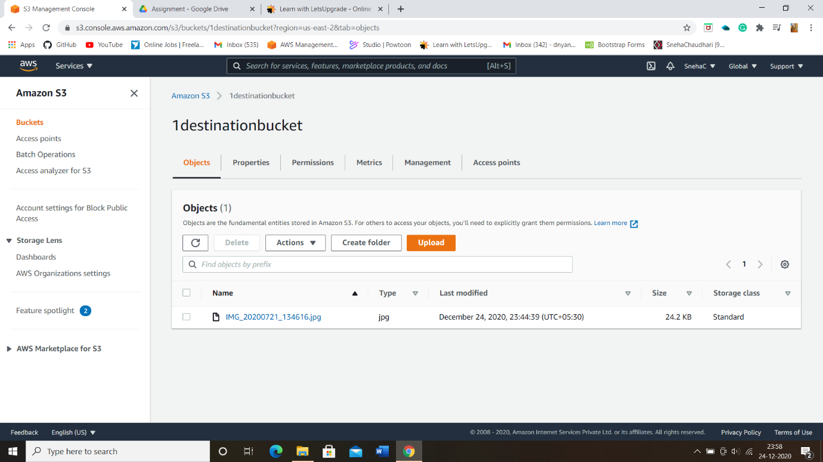

**------------------------------------------***-------------------------------------**

**2. Working with Elastic Container Service using fargate:-**

* Getting started with Amazon ECS using fargate:

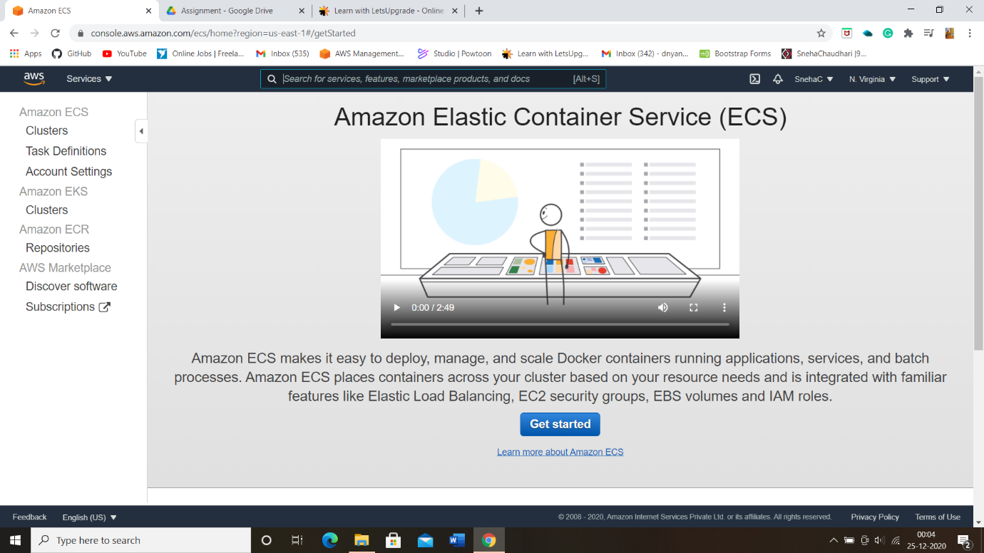

* Creating Container and Task:-

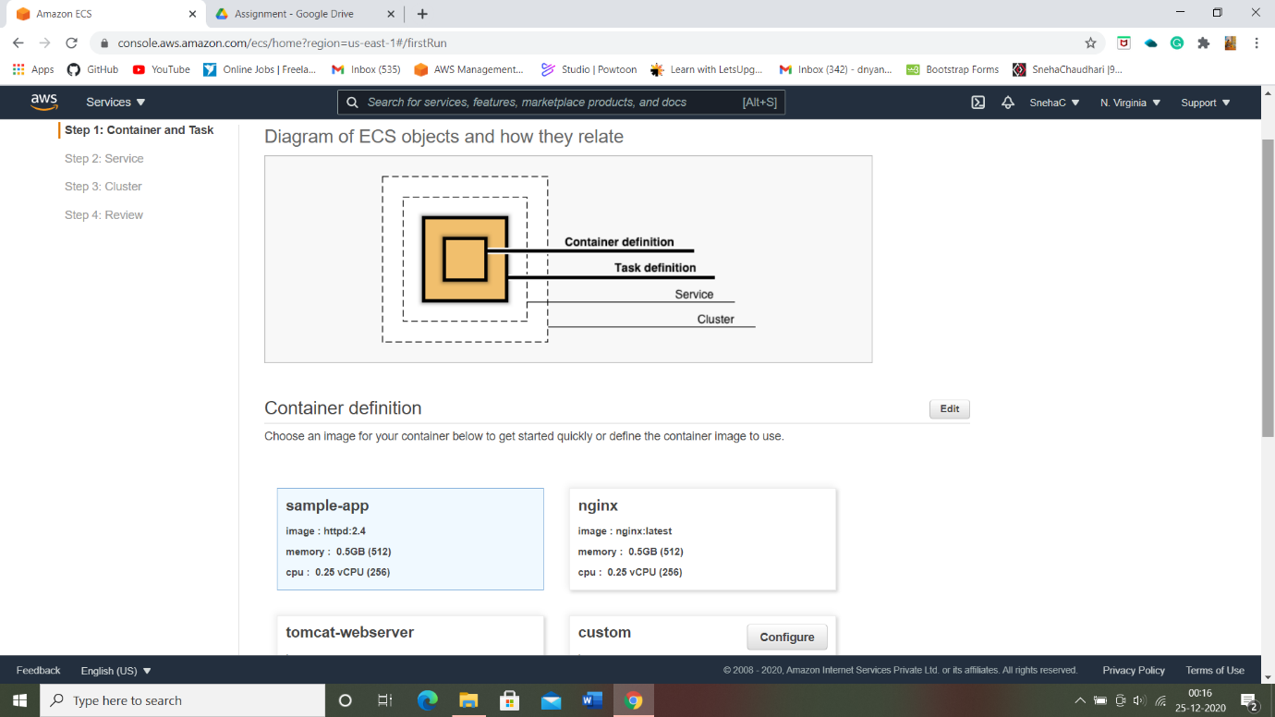

* Configuring the service:-

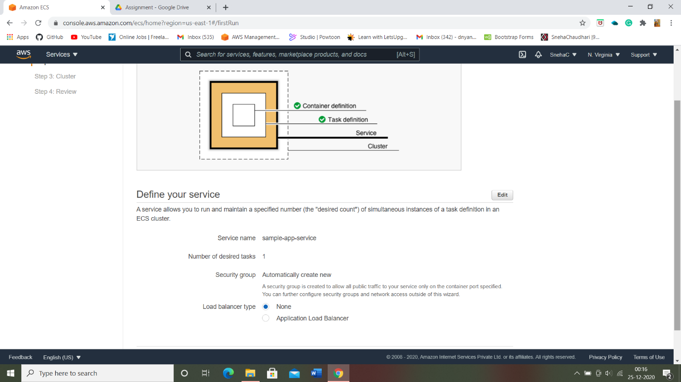Configuring the Clustter:-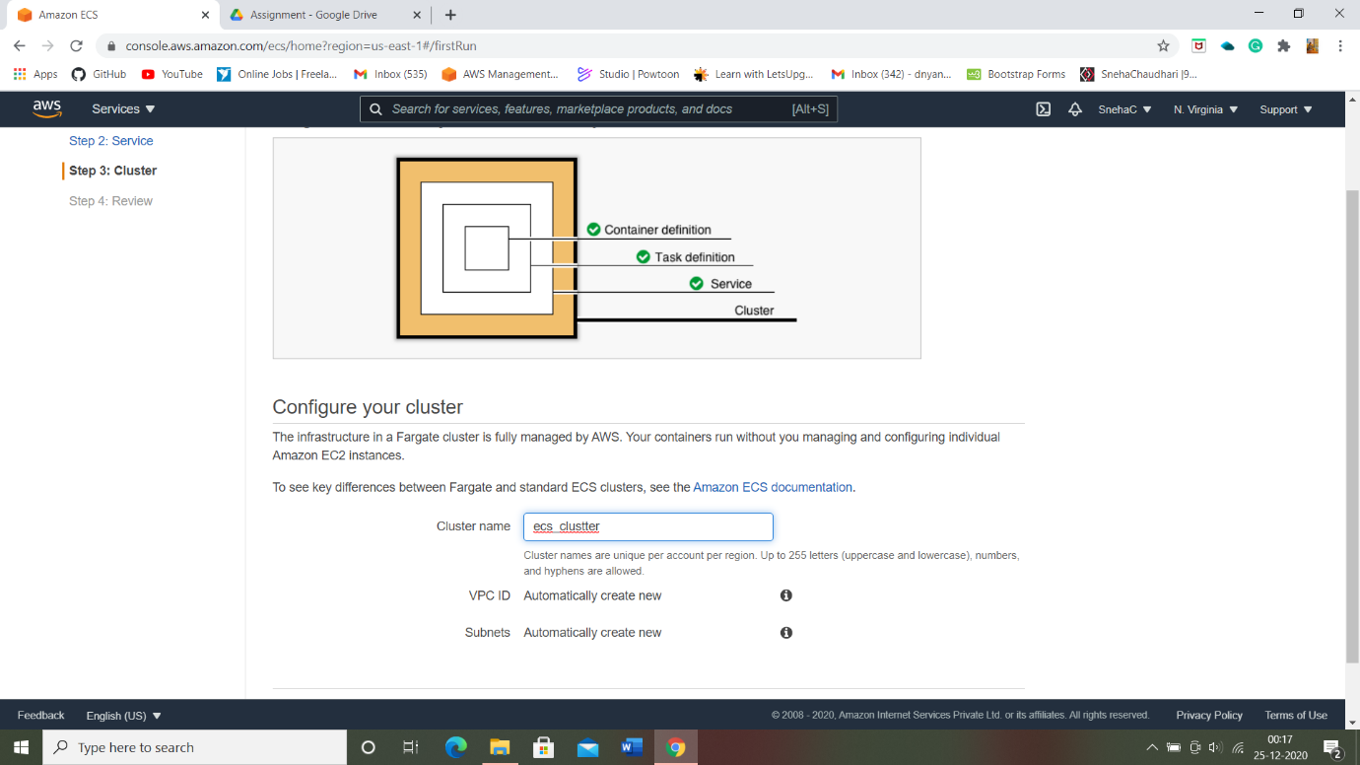

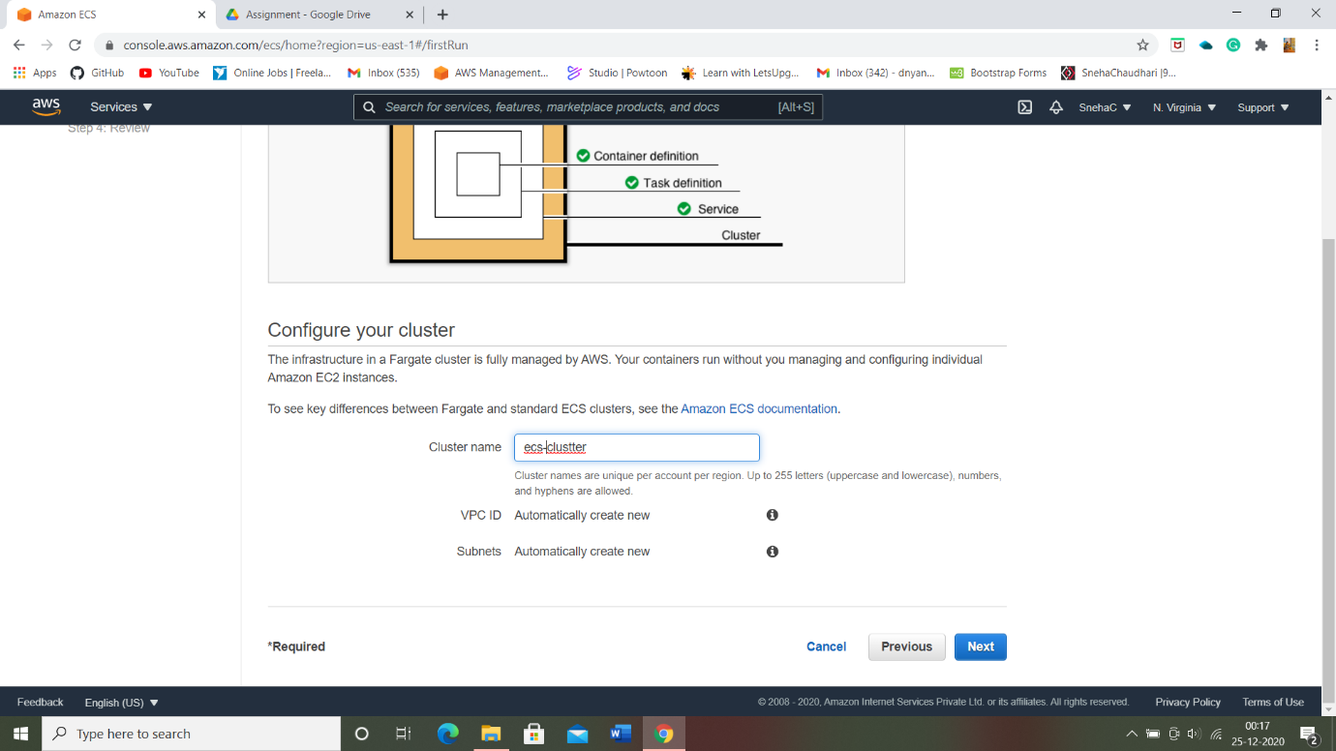

* Review of Amazon ECS:

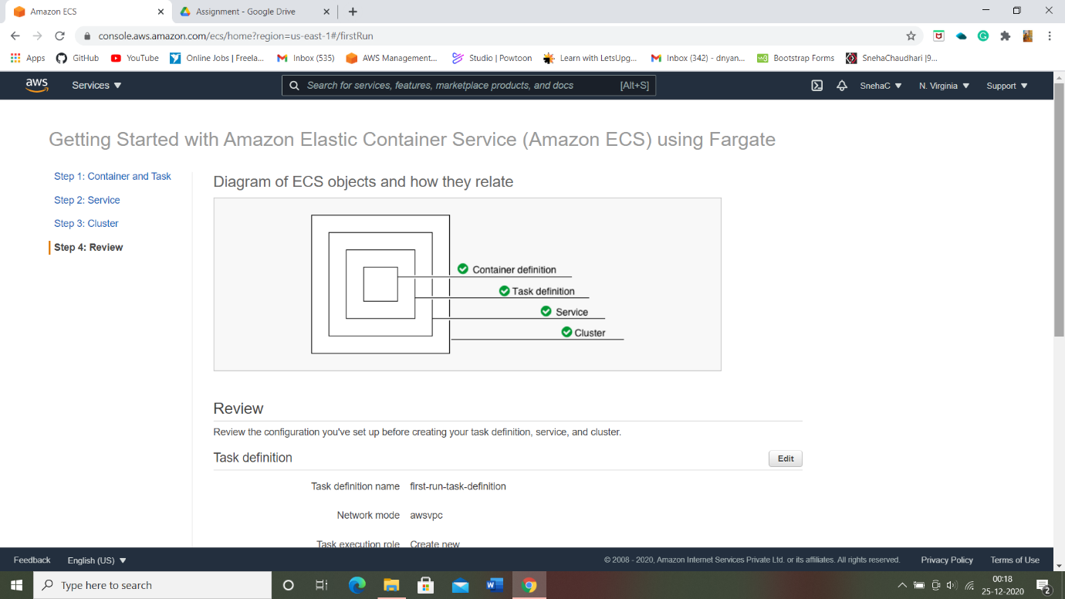

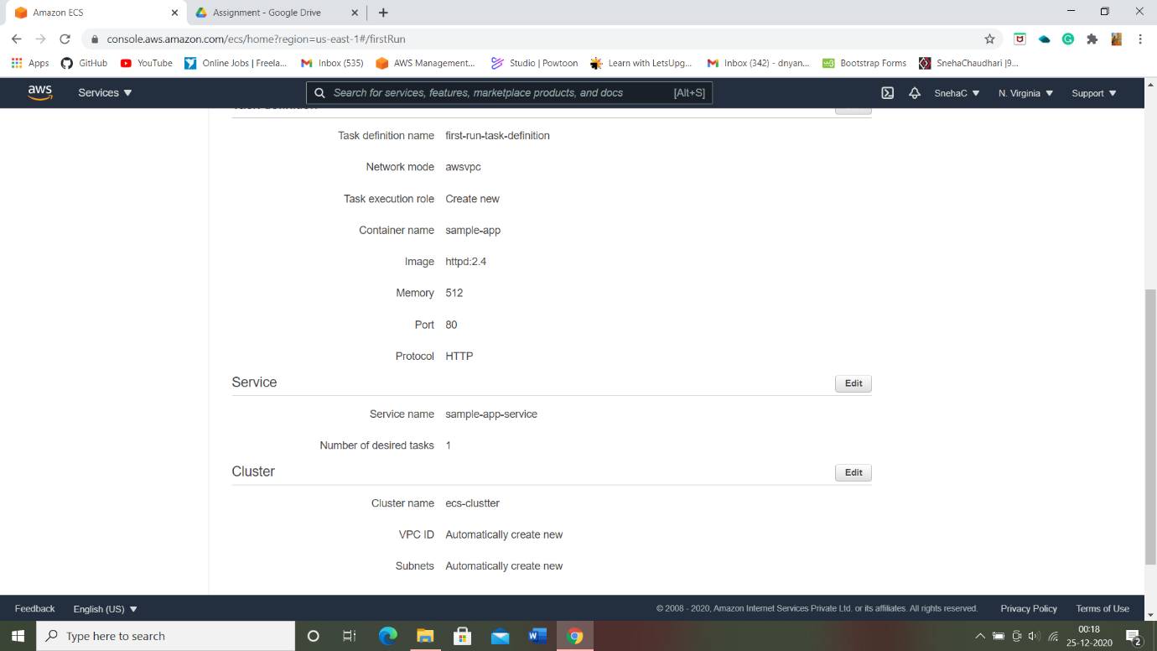

* Launcing ECS:

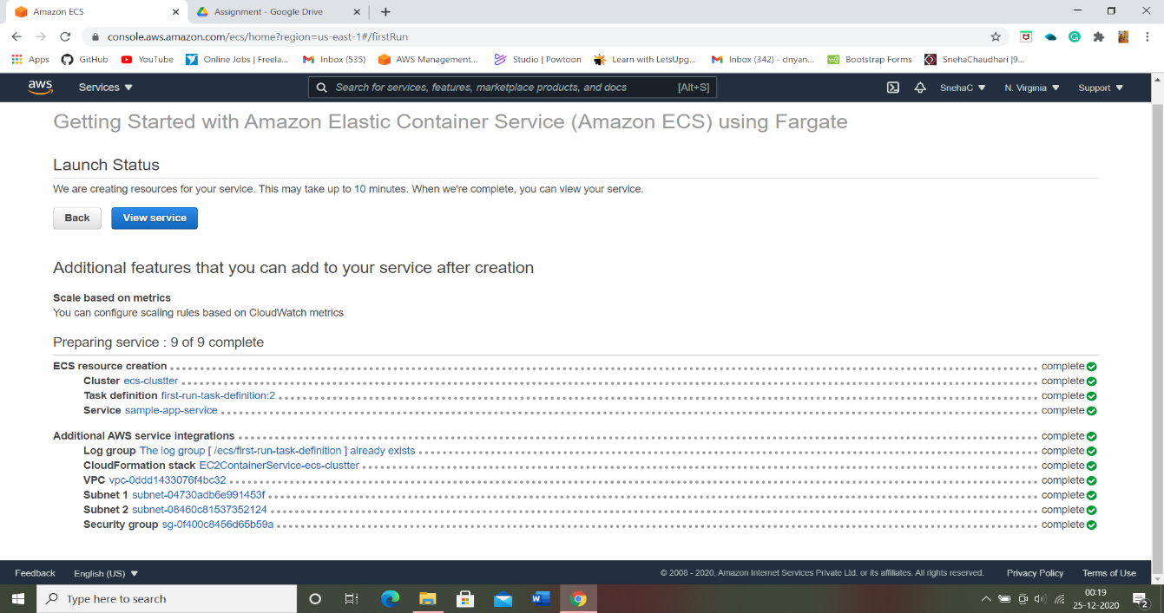

* Clustter information:

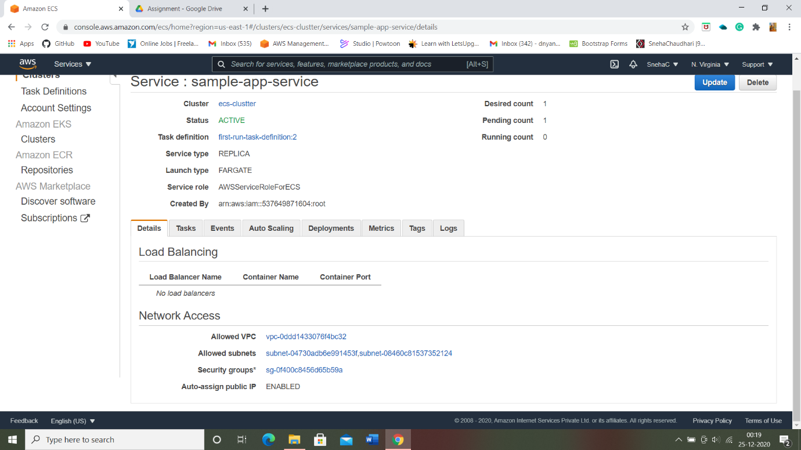

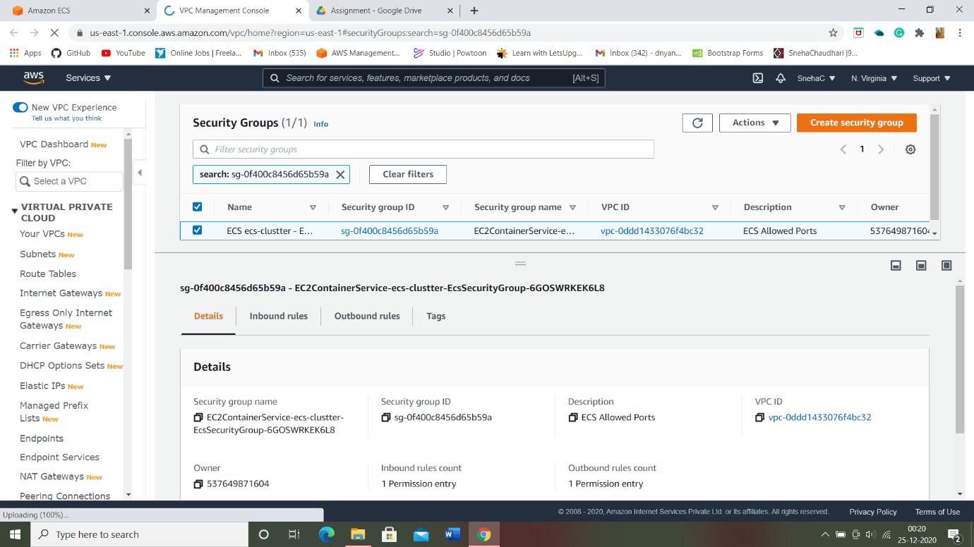

* ENI id, Private id, Public id, Mac address:

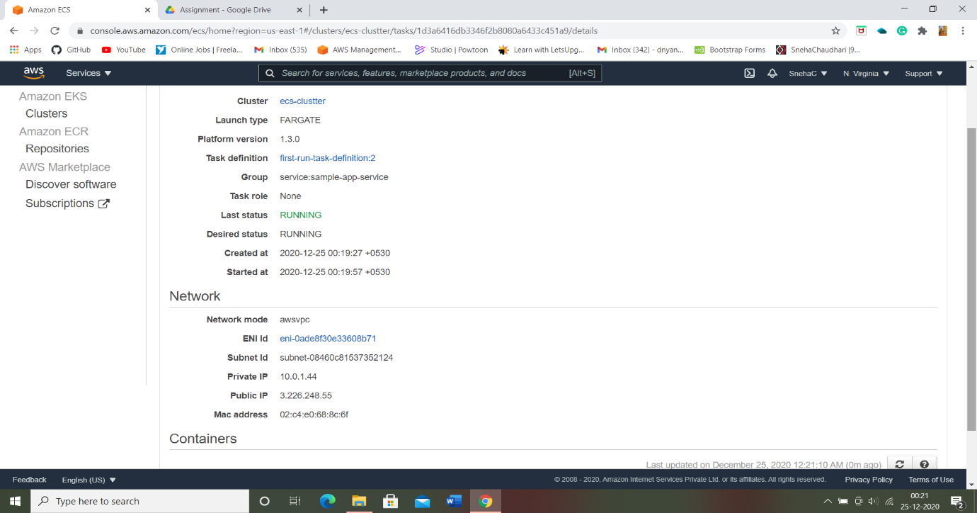

* Application running successfully:

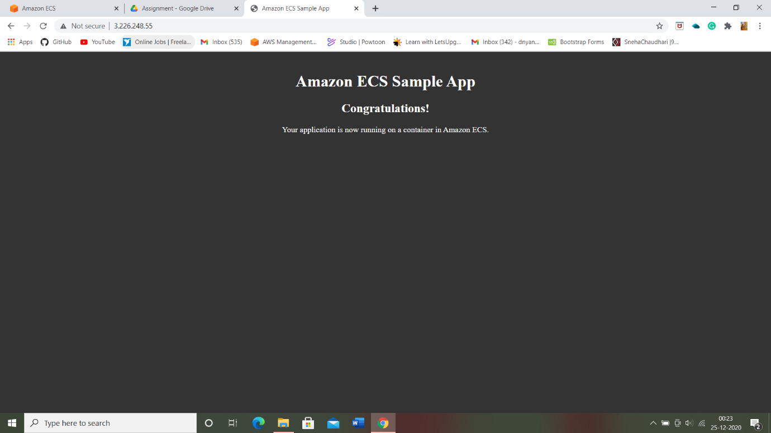

**----THE END----**